1. **HARDWARE COMPARAISON**

ODrive v3.4

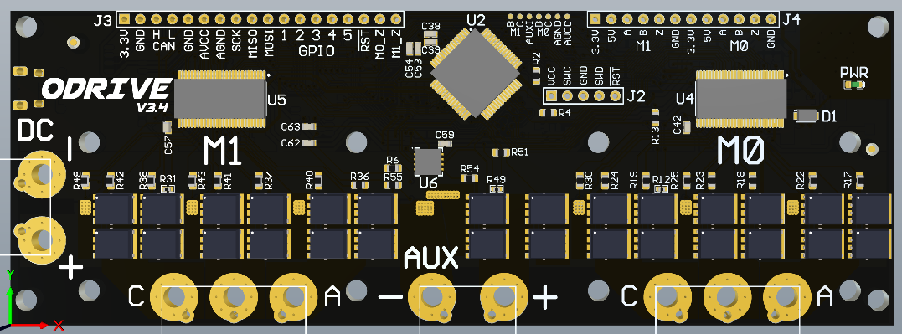 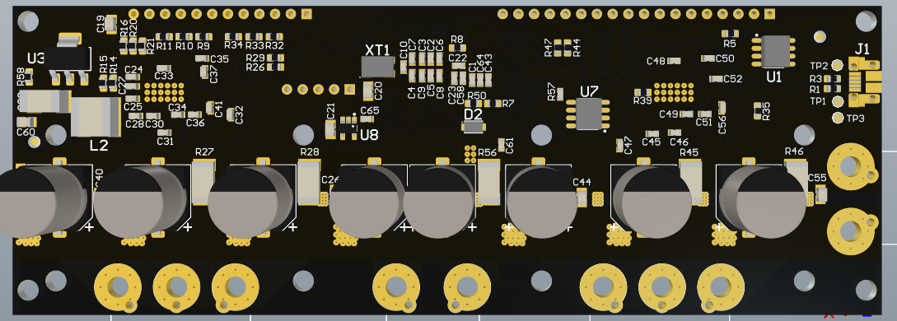

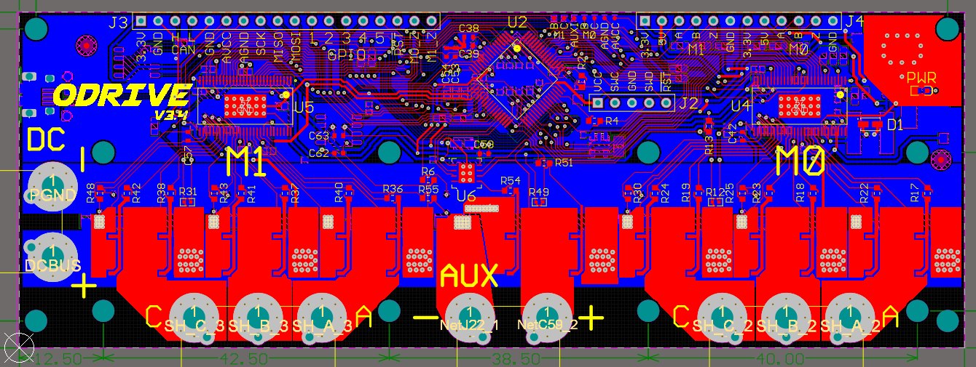

BDDrive : ODrive v3.4 modified

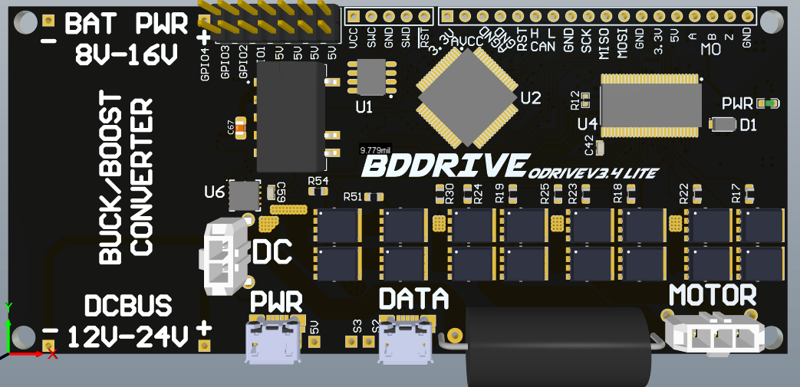 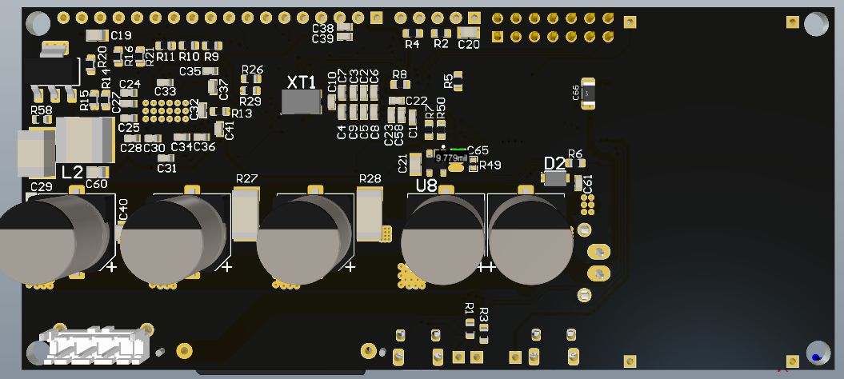

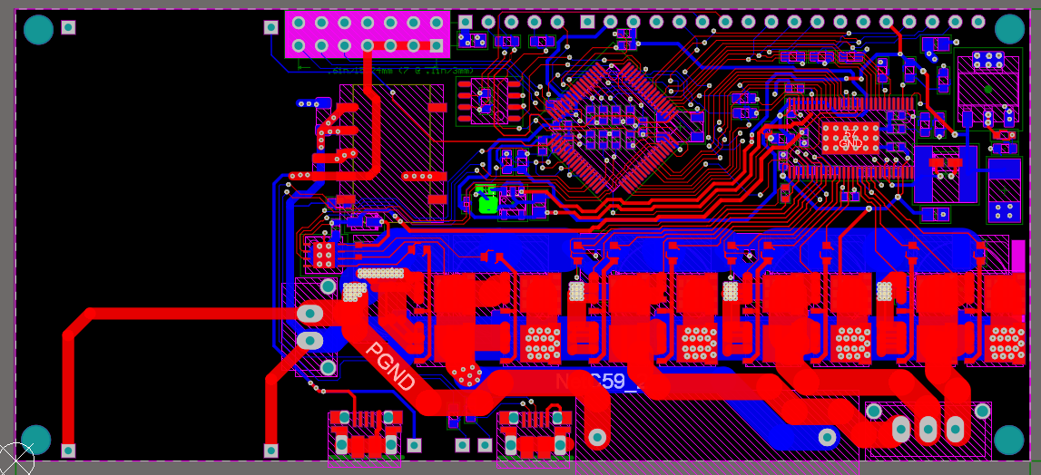

The polygon pours are not shown on this board, or else we wouldn`t see anything

1. **MODIFICATIONS**

* Remove support for two motors (remove M1), so right now BDDrive can only control one brushless DC motor
* Add support for a Buck/Boost converter breakout board soldered directly on the BDDrive
  + The breakout board needs to be within these specs: input from 8 to 16 volts and output configured as 12 to 24 volts
  + Don’t go over 24V (not even 24,5V), the BDDrive doesn’t support it
* Replace power resistor connector for a power resistor soldered directly on the board
  + Also, this resistor is rectangular (even though it is showed as round in the picture above) to be able to put mini heat sinks on it
* Use Molex connectors instead of screw in connectors to facilitate harness setup and the screw in connectors were proven as unreliable
* Add another 5V @ 1A power supply designed to power a Raspberry Pi with it (the power consumption of a Raspberry Pi Zero was estimated that the would be to be under 200 mA, so you can add 5V mini cooling fans with the 4 power pints available)
* Add external header with 5V supply outputs (4 power pins and 4 GND pins) and access to GPIO ports (3 GPIO pins and 3 GND pins)
* Add a power micro USB connector connected to the new 5V supply to power the Raspberry Pi
* Reroute a lot of components to minimize the size of the PCB
* Fix problems with the ODrive v3.4 which are documented here:
  + From the hardware GitHub: <https://github.com/madcowswe/ODriveHardware>
    - Check docs of v3.4 and v3.5 folders
    - Check CHANGELOG.md of v3 folder
  + <https://discourse.odriverobotics.com/t/drv-fault-on-odrive-v3-4/558?u=madcowswe>
  + Go from two layers to four layers to keep the GND uniformed
  + Fix routing problems
* Modify shunt resistors to be able to have a low power motor (below 5 Amps)
  + <https://discourse.odriverobotics.com/t/current-sensing-resistor-for-low-current-motors/377/2>
  + <https://discourse.odriverobotics.com/t/maxon-272763-motor/989/8>